| **Progress / RAG Report** | |
| --- | --- |
| **Weekly** | 2 |
| **Project:** | MH Investama Content Management Company Profile System |
| **Author:** | Mirza Putri (Product Owner) |
| **Sprint** | 1 |

|  |  |  |  |
| --- | --- | --- | --- |
| **Period Covering** | 16/04/2024 | **To**: | 25/04/2024 |

|  |  |
| --- | --- |
| **Overall Project Status** | High Priority |

|  |
| --- |
| Highlight Progress |
| Pada periode ini tim telah mempersiapkan beberapa hal yakni:   1. Menyelesaikan pengembangan module content management system pada halaman berikut (content masih berupa dummy inisiasi) 2. Menyelesaikan pengembangan fitur multilanguage |
| Call to Action:   1. MHI melakukan validasi terkait struktur konten yang ditampilkan di setiap page 2. MHI melakukan validasi terkait halaman <https://mhinvestama.azurewebsites.net/hubungan-investor/> dan memberikan informasi mengenai apa saja yang akan ditampilkan dalam konten tersebut  * Informasi apa saja yang akan ditampilkan dalam halaman ini? * Data untuk shareholder berupa apa?  1. MHI melakukan validasi terkait halaman <https://mhinvestama.azurewebsites.net/portofolio/portofolio-kami/>  * Informasi apa saja yang akan ditampilkan untuk masing-masing portfolio perusahaan?  1. Validasi terkait ukuran gambar, apa saja ukuran gambar dan asset yang disediakan? Kami sudah menggunakan asset dummy yang kami implement sebagai inisiasi content 2. MICE akan memberikan akses ke content management system saat seluruh tampilan dan struktur konten sudah divalidasi |

| **ID** | **Backlog** | **Status** | **Comment** |
| --- | --- | --- | --- |
| 2232 | User Manage Modul Landing Page/Home | Done | <https://mhinvestama.azurewebsites.net/> |
| 2233 | User Manage Modul About Us | Done | <https://mhinvestama.azurewebsites.net/tentang-kami/tentang-investama/> |
| 2234 | User manage Modul About Us – Vision | Done | <https://mhinvestama.azurewebsites.net/tentang-kami/visi-dan-misi/> |
| 2234 | User managae Modul About Us – Leadership | In Progress | <https://mhinvestama.azurewebsites.net/tentang-kami/kepemimpinan/> |
| 2235 | User manage Modul about us – Structure | Done | <https://mhinvestama.azurewebsites.net/tentang-kami/struktur-keanggotaan/> |
| 2236 | User manage Modul Our Portfolio | Done | <https://mhinvestama.azurewebsites.net/portofolio/portofolio-kami/> |
| 2237 | User manage Modul Listed Portfolio | In progress | https://mhinvestama.azurewebsites.net/portofolio/performa-portofolio/ |
| 2238 | User manage Modul Investor Relations | Done | <https://mhinvestama.azurewebsites.net/hubungan-investor/> |
| 2239 | User manage Modul News Room | Done | <https://mhinvestama.azurewebsites.net/ruang-berita>  <https://mhinvestama.azurewebsites.net/ruang-berita/xyz-investment-firm-announces-record-breaking-growth-in-q2-performance-2/> |
| 2240 | User manage Modul contact | Done | <https://mhinvestama.azurewebsites.net/kontak/> |
| 2241 | User can manage content in multilanguage | Done | Website can be switched to another language  <https://mhinvestama.azurewebsites.net> for domain ID  <https://mhinvestama.azurewebsites.net/en> for domain ENG |
| 2242 | User search something by tag/keyword | In progress |  |
| 2243 | User role-based access control and permission | In progress |  |

Content management system development

2232 User Manage Modul Landing Page/Home

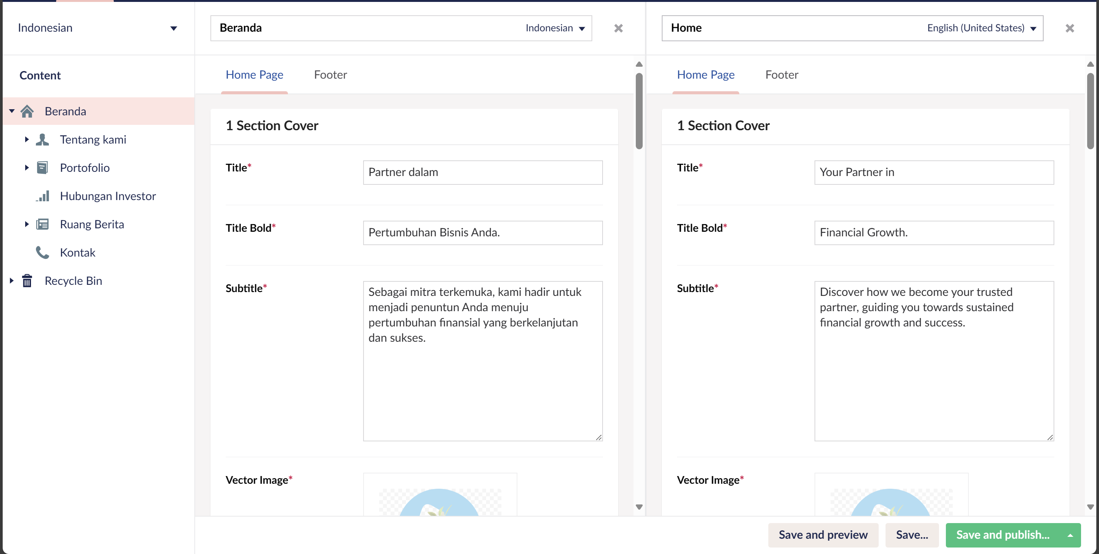

2233 User Manage Modul About Us

2234 User manage Modul About Us – Vision

2235 User manage Modul about us – Structure

2236 User manage Modul Our Portfolio

2239 User manage Modul News Room

2240 User manage Modul contact

